It is possible to change the font size, as well as other properties of the text within a dashboard. To do so is fairly easy since charts, which are used with dashboards have “style” properties which can take CSS into them so you can manipulate the text of the style sheet.   To do this I will outline some steps for you to follow.

1. From the TOC navigate to Administration->Dashboards
2. Select the Dashboard you want and open in edit mode
3. Right click on one the Dashboard Chart you would like to change and click on view chart

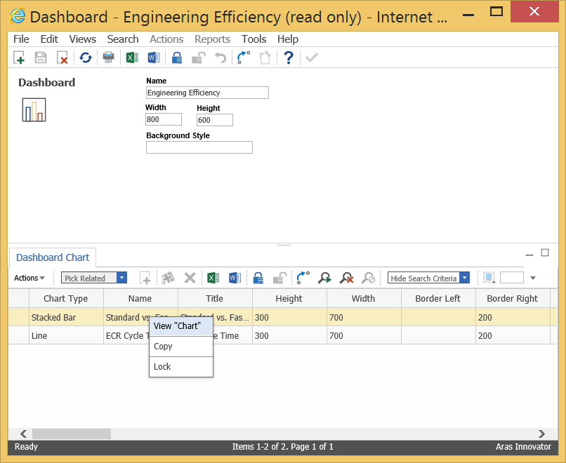

1. Lock the chart
2. As seen below with some of them circled in Yellow, the chart has some styles which you can insert CSS into to allow you to change how the font is seen.  By using the CSS you can change the font style, size, color etc.  So for example for a font size of 20 in Century Gothic for the title you would enter into the “Title Style” text box “font: 20px Century Gothic,CenturyGothic,AppleGothic,sans-serif;”

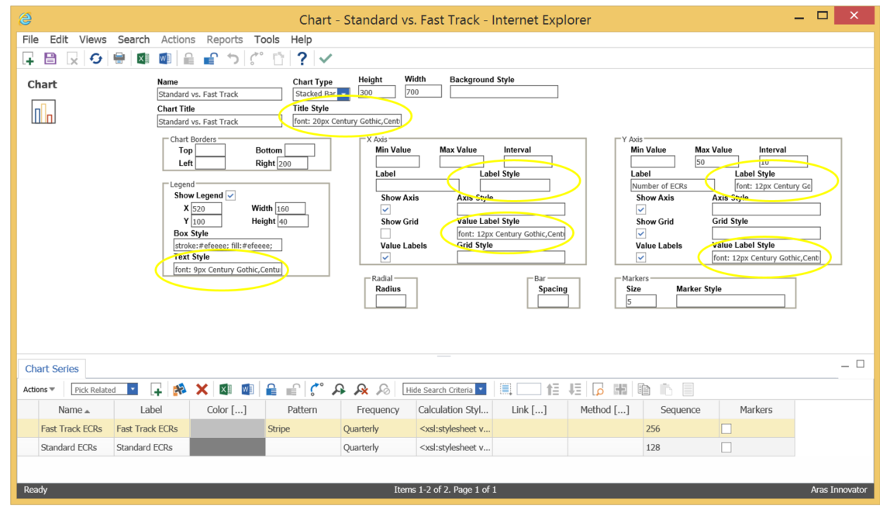

1. Save, unlock, and close both the Chart and the Dashboard
2. The changes should take effect immediately